YURI ELIK
Photographer, video artist and VJ.
Author of several audiovisual installations and performances, both solo or as a member of various multimedia collectives. Actively collaborates with various musicians, making live video and/or slide shows for such musical groups as APosition Orchestra, Totalitarian Musical Sect, Theodor Bastard, DaDaZu, Damo Suzuki, Zelany Rashoho, Noises of Russia, Soyuz Kommercheskogo Avangarda, Mandelbrot, Bardoseneticcube, Hladna, AL.exe, Vershki da Koreshki, Ole Lukkoye, V.O.M., Tanja "SWA" Kalmykova, Eat Static, Zero Gravity Thinkers and others. In 2003 made video show for the ballet Simon Magus by D.Kahovskiy (staged in St.Petersburg and Berlin in 2003). Big experience as a VJ includes one and a half ears of regular work at The PLACE club in St.Petersburg, Russia and long-lasting collaborations (as a VJ and video artist) with festivals SKIF, Aposition, Stereoleto, Space of Joy and others.
Member of multimedia project 2012. Beginning from the first performance in 1998 took part in performances and installations of the group.
Since 2002 started developing original techniques of hand-drawn slides for 2012 performances as well as in solo projects (of which the co-operation with Totalitarian Musical Sect should be noted).
In 2006 founded Project503 together with musician Pavel Mikheev (DaDaZu, Eject, Rtut’ and others). Their audiovisual performance FEED BACK was presented at festivals in Russia (SKIF10), Finland (amorph!06) and USA (Habitats). Later same year became one of the members of the Russian-American multimedia project Silence Corporation. Member of Ygo, Regis III and The Frozen Orchestra.
Made design for CDs of groups 2012, Ole Lukkoye, Totalitarian Musical Sect. The design for audio CD of Simon Magus ballet won the prize of Index Design magazine. Made web-sites for the groups Ole Lukkoye, Vershki da Koreshki, Tribe of Cro.
Since the beginning of 2007 organizing, together with Aleksej Pljusnin and Pavel Mikheev, weekly SHARE event (multimedia jam and experience exchange) in St.Petersburg, Russia.

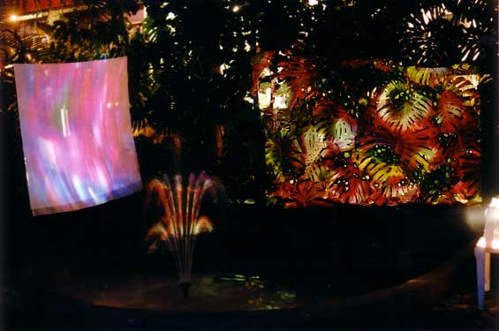  THIRD GARDEN installation with Group 2012  (SKIF7 festival, St.Petersburg, Russia 2003) | 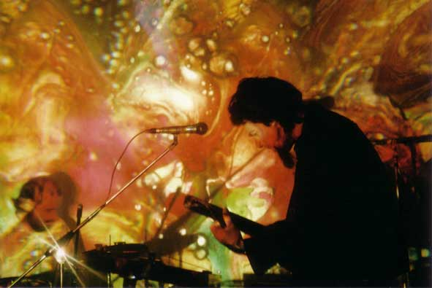  Dynamic slide show with Totalitarian Musical Sect  (Gallery of Experimental Sound, St.Petersburg, Russia, 2004)
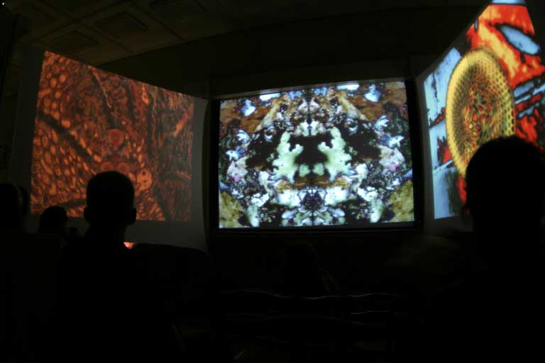  CONTACT WITH MICRO WORLD installation  (Botanical Museum, St.Petersburg, Russia 2005) | 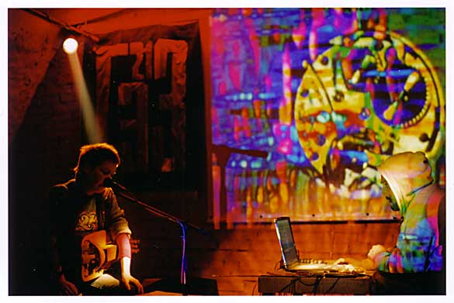  Video performance for Noises of Russia  (Gallery of Experimental Sound, St.Petersburg, Russia, 2005)
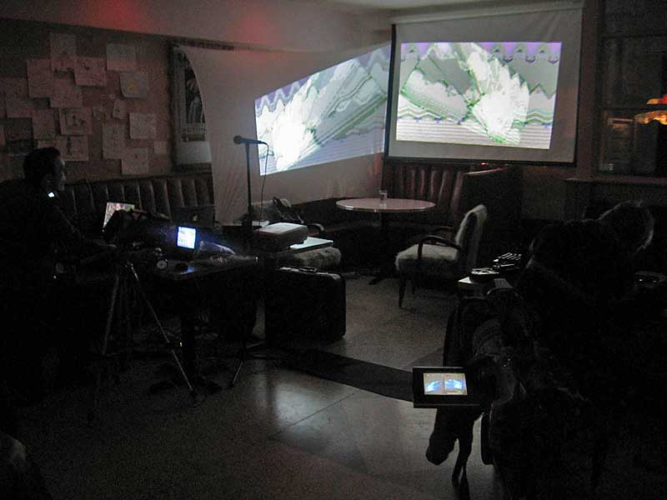  Project503 with FEED BACK performance  (SHARE at New York City, USA, 2006) | 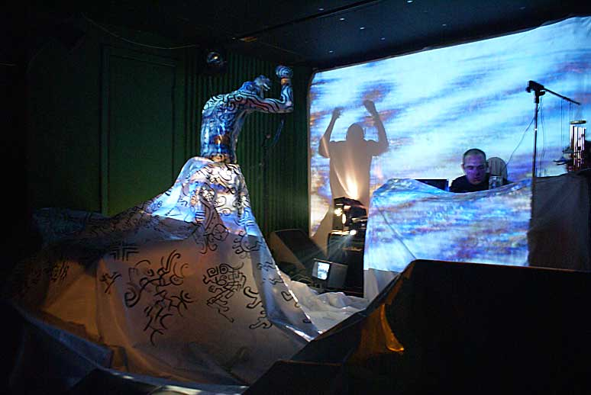  MEDIAFORM performance with BARDOSENETICCUBE  (Zoccolo, St.Petersburg, Russia, 2007)

Photo exhibitions:
- PSY-CHE-DEL-I-CA, Alt-Gallery 103, Free Culture Foundation, St.Petersburg (1998)
- Neitralnaja Polosa, Borey Gallery, St.Petersburg (2001) – with S.Neljubina
- GESology, GES-21, Free Culture Foundation, St.Petersburg (2002)
- City Spirits, Internet Center 5.3GHz, St.Petersburg (2005)
- CONTACT WITH MICROWORLD, Botanical Museum, St.Petersburg (2005)

Installations:
- TRANCEPARENCE, SKIF5 festival (2001) - with 2012
- RE_NATURE, SKIF6 festival (2002) - with 2012
- THIRD GARDEN, SKIF7 festival (2003) - together with noise musician O.Repin
- WHITE YURT, Dutch SKIF festival (2003)
- BUBBLE, SKIF9 and Diverse Universe festivals (2005) - collaboration with Amoeba Technology (USA)
- CONTACT WITH MICRO WORLD, St.Petersburg, Russia (2005), New York, USA (2006)

Selected video works
- PSY CRICKETS (2000, 7 min.) – video art work (as member of Group 2012)
- LUCHЪ (2004, 28 min.) – concert of Totalitarian Musical Sect with Peter Broetzmann
- Voices of the Dead (2005, 10 min.) - video art work on music by Noises of Russia and Y.Elik
- City Spirits (2005, 12 min.) - slide film made from Y.Elik's photos
- Mandelbrot (2006, 26 min.) - video art work on music by Mandelbrot
- FEED it BACK (2006, 62 min.) – live and studio works by Project503
- ETC Studies (2006, 33 min.) – works created at the Experimental Television Center, USA
- Gusli (2009, 24 min) – scene from life of Russian folk musicians

Festivals:
- Solipse (Ozora, Hungary, 1999)
- Forces of light (Gloria Hall, Helsinki, Finland, 1999)
- SKIF 4, 5, 6, 7, 8, 9, 10, 11, 12 (St.Petersburg, Russia, 2000-2008)
- SKIF Berlin (Berlin, Germany, 2003)
- Dutch SKIF (St.Petersburg, Russia, 2003)
- Fotomarathon (St.Petersburg, Russia, 2002, 2005)
- Multivision (St.Petersburg, Russia, 2003-2004)
- Themes and Variations (St.Petersburg, Russia, 2004)
- Ethnolife (St.Petersburg, Russia, 2004)
- Stereoleto (St.Petersburg, Russia, 2004 - 2008)
- Noise vs. Glamour (Moscow, SPb, Russia, Helsinki, Finland, 2004-2006, 2009)
- Diverse Universe (Helsinki, Finland, 2005)
- Thalamus 2 (Pskov, Russia, 2005)
- Thalamus 3 (St.Petersburg, Russia, 2007)
- Body Navigation (St.Petersburg, Russia, 2005, 2007-2009)
- Contemporary Art in Traditional museum (St.Petersburg, Russia, 2005)
- APosition Musical Forum (St.Petersburg, Russia, 2005-2009)
- Zodiak – Z-in-motion (Helsinki, Finland, 2006)
- amorph!06 (Helsinki, Finland, 2006)
- habitats (New York, USA, 2006)
- Cosmonoise (St.Petersburg, Russia, 2006-2009)
- Sisto Palty (St.Petersburg, Russia, 2008, 2009)
- Khan Altay (Altaj Mountains, Russia, 2008)
- Ethnomechanica World Music&Arts Festival (St.Petersburg, Russia, 2008)
- Electro-Mechanica (St.Petersburg, Russia, 2008, 2009)
- Space of Joy (Crimea, Karpatiians, Ukraine, 2009)
- Long Arms (Moscow, Nizny Novgorod, Russia, 2009)

Residencies:
- Experimenta Television Center (Owego, NY, USA, 2006)

Links:
- Yuri Elik: http://www.youtube.com/user/vjYuriElik
- SHARE SPb: http://sharespb.spb.ru/

